STONEHAVEN TOWN PARTNERSHIP
Minutes of Board Meeting
held on 22nd February 2011
at the Invercarron Resource Centre, Stonehaven

 | Item | Action
1. | Welcome & apologies  Present: Cllr Peter Bellarby (chair), David Fleming, Niall Menzies, Dennis Collie (DC)  Minute Secretary: David Fleming  In attendance: Karen McWilliam, Diane Collinson (DColl)  Apologies: Steven Holt, Pam Dobbie
2. | Minutes from last meeting (27th January 2011)  Approval  The minutes had been circulated. They were agreed.  Actions – not referred t elsewhere  DF has written to Lesley MacDonald.  Directors  No more candidates had been identified.
3. | Finance  Finance Report  DC reported a bank balance of £3,453, with a £200 refund from the Inland Revenue and £5,000 from Aberdeenshire Council still to be banked.  Financial Procedures  DF reported that the bank had received the form for change of signature, and that he had passed all the papers over to DC.  Presentation to Kincardine & Mearns Area Committee  It was decide that the presentation to the Area Committee would be done by PB and DF, and that the Project report provided the basis for the content. KMcW stated that the deadline for the draft was 3/3/11. | PB/DF
4. | Involvement of more organisations  Web site  It was decided that the web site needed immediate update. NM agreed to contact George McGillivray.  Newsletter  It was decided that we need to generate a newsletter.  Membership renewal  It was decided that we needed to circulate existing members, giving reasons why they should join in and be involved, the current projects, and why they should arrange to talk to each other.  Timing  It was felt that these last two activities should be arranged after the next meeting, by which time, hopefully, all the project details would be firmed up. | NM
5. | Proposed ‘Planning for Real’ exercise  The working group had met, and their output is summarised in a paper.  These principles were accepted, but the area was extended to include Baird Park and Cowie Mill, thus:  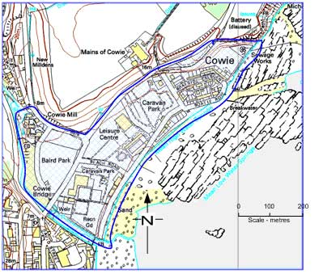  It was decided that the working group should meet again to draw up more details of timetable, budget and list of stakeholders and contacts.  Then a brief could be sent out. Contacts (to start once the brief was ready) were agreed as follows:  Friends of the Open Air Pool PB  Recreation Ground Trustees PB  Skatepark Group DF  Business Assoc NM  Allotment Assoc DF  Primary Schools PB  CLD/Youth Group KMcW  Sarah D Group PB
6. | Proposed Projects for support  The update of the draft of the list of proposed projects was discussed thoroughly.  The ‘projects on hold’ list was agreed.  In the “Do Now” list, the following actions were agreed:  - Central Ticket Office This needs to be followed up by SH  - Food Town Initiative Robert Armstrong needs to be involved, and the Business Association will discuss it on 1/3  - Tourist Brochure Costs awaiting; some question on sustainability  - MRI Conference Centre DF to get update from Ann Laing  - Planning for Real Agreed – see item 5 above.  - Business Improvement District Bus Assoc to discuss further; Aberdeenshire Council policy awaited  - Info about volunteers MAP booklet requested  - Training towards trusts Agreed to join Development Trusts Association, and seek their help  - Talking Newspaper Grant of half – i.e. £994 agreed | SH  NM  NM  DF  All  NM  Willie Munro/ Robert Armstrong  DColl  DF  DC
8. | Future of Aberdeenshire Council assets  Letter to Dr. Collete Backwell  This had been sent, but no reply received yet. PB is aware that some discussions are underway within Aberdeenshire Council to set out a clear process for all the asset transfer ideas.  Tolbooth Museum  A meeting is planned for 2nd March. PB will attend on behalf of STP (DF will be there on behalf of S&DCC).  Caravan Park  No action has been taken.
7. | Meeting with Stonehaven & District Community Council  It was agreed that this would be worthwhile, and DF was asked to organise it. | DF
8. | A.O.C.B.  None
12. | Date of the next meeting  22nd March 2011 at 7:30 pm.

